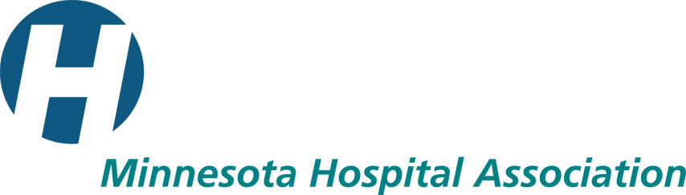

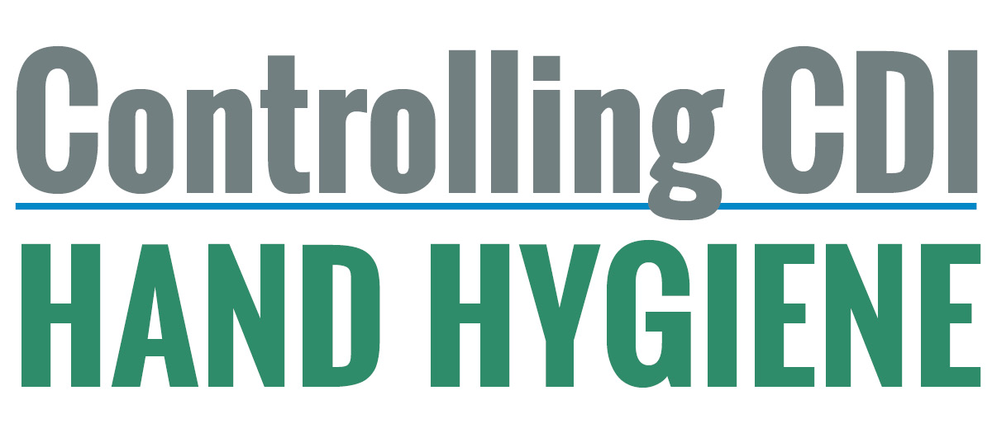Introduction and summary

Human Factors is the study of how humans interact with the world around them. Studying how people interact with equipment and materials allows us to change the environment in which we work to make the interaction more useful or helpful. A user-friendly hand hygiene environment is one where staff, patients and visitors are supported in such a way that participating in optimal hand hygiene activities can take place in the right place and at the right time (Canadian Patient Safety Institute, 2013).

The Human Factors Approach to Hand Hygiene Tool Kit has been compiled from materials produced by the Canadian Patient Safety Institute (CPSI) and the World Health Organization (WHO). Funded by the Centers for Medicare and Medicaid Services’ Leading Edge Advanced Practice Topics (LEAPT), the Minnesota Hospital Association, along with representatives from a group of Minnesota hospitals, adapted the materials in effort to provide a streamlined and innovative approach to improve hospital staff hand hygiene compliance. It is important to include Facilities Management in the implementation of this tool kit so that all hand hygiene equipment and supply placement is in compliance with environmental safety regulations and codes.

The Hand Hygiene Environmental Assessment Tool was designed to provide an assessment of the degree to which products and equipment support hand hygiene compliance by hospital staff. The tool is based on the human factors principles of visibility, consistency, efficiency, accessibility and error prevention.

- Visibility – products and equipment will be seen by staff and provide a reminder to clean their hands.
- Consistency – equipment and products are in a similar location or pattern across a setting to employ repetition and predictability in enhancing compliance.
- Efficiency – the environment promotes staff hand hygiene with the least amount of effort.
- Accessibility – equipment and products are placed within easy reach of staff.
- Error prevention – equipment and products are placed in such a way that it easier to do the right thing.

The Sticker Placement Activity is designed to elicit staff input in the placement of hand hygiene equipment and products. Considering staff direction in the arrangement of their work environment promotes compliance by leveraging their expertise as well as promoting empowerment. The majority of staff surveyed during the pilot testing of this tool kit preferred to be reminded to perform hand hygiene by peers. Abbott Northwestern Hospital graciously shared this “Approach and Coach” video to equip staff to help each other remember to consistently perform hand hygiene. http://www.mnhospitals.org/controllingcdi/#anhvid.

The Hand Hygiene Perception Survey, adapted from WHO’s Staff Perception Survey provides insight into the barriers staff encounter in attempting to engage in proper hand hygiene. The survey should be performed at the beginning of the project to establish a baseline and at the conclusion of the project to determine whether human factors and staff guided interventions have decreased staff-perceived barriers to hand hygiene.

Observational hand hygiene audits should be performed throughout the course of the project to measure improvement in compliance as a result of interventions. Three examples of hand hygiene audit tools are provided for hospitals to choose from or to use as a guide to design their own.

The Minnesota Hospital Association acknowledges the contributions and hard work of the following LEAPT Controlling CDI mentor hospitals

Mentor hospitals:
- Park Nicollet Methodist Hospital, Minneapolis (M)
- University of Minnesota Medical Center, Fairview, Minneapolis (M)
- United Hospital, Saint Paul, part of Allina Health (M)
- Exploratory hospitals:
- Windom Area Hospital
- Minnesota Valley Health Center, Le Sueur
- Grand Itasca Clinic and Hospital, Grand Rapids
- CentraCare Health – Melrose
The Minnesota Hospital Association acknowledges with gratitude the following organizations for permission to adapt tools and resources for inclusion in this tool kit

- Canadian Patient Safety Institute:
http://www.handhygiene.ca/English/Tools/Pages/Human-Factors-Toolkit.aspx

- “Perception Survey for Health-Care Workers”:
http://www.who.int/gpsc/5may/tools/evaluation_feedback/en/index.html
World Health Organization 2009. All rights reserved.

Additional Resources

- Hand hygiene is only one of the interventions known to control CDI. Environmental cleaning is addressed in the MHA LEAPT Controlling CDI Environmental Cleaning and Supervision Training Model, to be introduced to Minnesota hospitals in June 2014. Will be available on MHA’s website in June: http://www.mnhospitals.org/controllingcdicleaning
- The Minnesota Department of Health has developed a hospital antimicrobial stewardship program, accessible at the following link: http://www.health.state.mn.us/divs/idepc/dtopics/antibioticresistance/mnasp.pdf

- Collaborative for Healthcare Associated Infection Network (CHAIN) has developed a CDI gap analysis, or roadmap, accessible at the following link: http://www.mnreducinghais.org/documents/HAIGapAnalysisCDI.PDF

